DATA SCIENCE LAB RECORD

SUBMITED BY,
ANJITHA K KAMAL
ROLL NO:20MCA014

CYCLE-1

1. Program to Print all non-Prime Numbers in an Interval

PROGRAM
start = 11
end = 25
for i in range(start, end + 1):
if i > 1:
for j in range(2, i):
if (i % j == 0):
break
else:
print(i)
OUTPUT
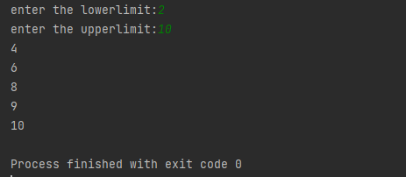

2. Program to print the first N Fibonacci numbers.
PROGRAM

def printFibonacciNumbers(n):
f1 = 0
f2 = 1
if (n < 1):
return
print(f1, end=" ")
for x in range(1, n):
print(f2, end=" ")
next = f1 + f2
f1 = f2
f2 = next

printFibonacciNumbers(7)
OUTPUT
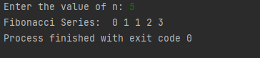

3. Given sides of a triangle, write a program to check whether given triangle is an isosceles, equilateral or scalene.

PROGRAM
def checkTriangle(x, y, z):

if x == y == z:
print("Equilateral Triangle")

elif x == y or y == z or z == x:
print("Isosceles Triangle")

else:
print("Scalene Triangle")

x = input("enter the first side")
y = input("enter the second variable")
z = input("enter the third variable")
checkTriangle(x, y, z)
OUTPUT
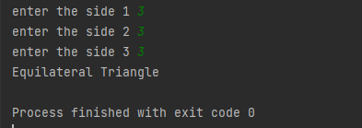
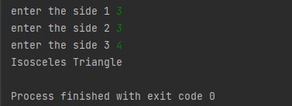
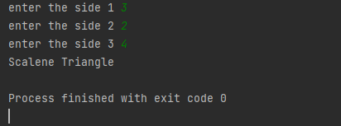

4. Program to check whether given pair of number is coprime
PROGRAM
def __gcd(a, b):
if (a == 0 or b == 0): return 0
if (a == b): return a
if (a > b):
return __gcd(a - b, b)
return __gcd(a, b - a)
def coprime(a, b):
if (__gcd(a, b) == 1):
print("Co-Prime")
else:
print("Not Co-Prime")
a = 5;
b = 6
coprime(a, b)
a = 7;
b = 8
coprime(a, b)
OUTPUT
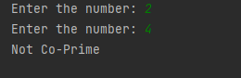
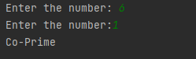
5. Program to find the roots of a quadratic equation(rounded to 2 decimal places)
PROGRAM
from math import sqrt
print("Quadratic function : (a * x^2) + b*x + c")
a = float(input("a: "))
b = float(input("b: "))
c = float(input("c: "))
r = b ** 2 - 4 * a * c
if r > 0:
num_roots = 2
x1 = (((-b) + sqrt(r)) / (2 * a))
x2 = (((-b) - sqrt(r)) / (2 * a))
print("There are 2 roots: %f and %f" % (x1, x2))
elif r == 0:
num_roots = 1
x = (-b) / 2 * a
print("There is one root: ", x)
else:
num_roots = 0
print("No roots, discriminant < 0.")
exit()
OUTPUT
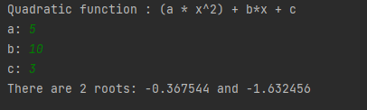
6. Program to check whether a given number is perfect number or not(sum of factors
=number).
PROGRAM
n = int(input("Enter any number: "))
sum1 = 0
for i in range(1, n):
if(n % i == 0):
sum1 = sum1 + i
if (sum1 == n):
print("The number is a Perfect number!")
else:
print("The number is not a Perfect number!")
OUTPUT
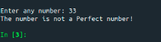

7. Program to display amstrong numbers upto 1000
PROGRAM
lower = int(input("Enter lower range: "))
upper = int(input("Enter upper range: "))

for num in range(lower, upper + 1):
sum = 0
temp = num
while temp > 0:
digit = temp % 10
sum += digit ** 3
temp //= 10
if num == sum:
print(num)
OUTPUT
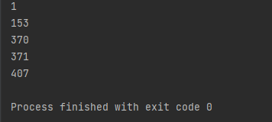
8. Store and display the days of a week as a List, Tuple, Dictionary, Set. Also
demonstrate different ways to store values in each of them. Display its type also.
PROGRAM
l = []
l.append(5)
l.append(10)
print("Adding 5 and 10 in list", l)

# Set
s = set()

s.add(5)
s.add(10)
print("Adding 5 and 10 in set", s)

# Tuple
t = tuple(l)

print("Tuple", t)
print()

# Dictionary
d = {}

d[5] = "Five"
d[10] = "Ten"
print("Dictionary", d)
OUTPUT
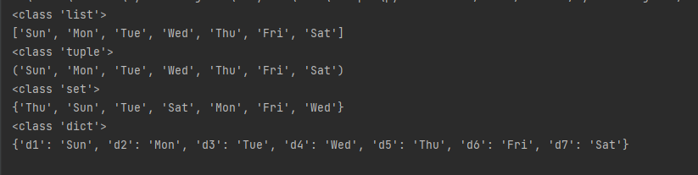
9. Write a program to add elements of given 2 lists
PROGRAM
l = [5,6,7,8]
k=[1,2,3,4]
print("list 1 element ", l)
print("list 2 element", k)
res_list = [l[i] + k[i] for i in range(len(l))]

print("Resultant list is : " + str(res_list))
OUTPUT
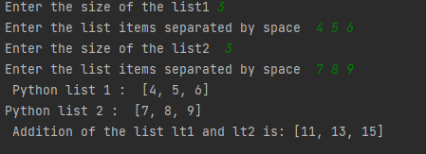
10. Write a program to find the sum of 2 matrices using nested List.
PROGRAM
matOne = []
print("Enter Elements for First Matrix: ")
for i in range(3):
matOne.append([])
for j in range(3):
num = int(input())
matOne[i].append(num)

matTwo = []
print("Enter Elements for Second Matrix: ")
for i in range(3):
matTwo.append([])
for j in range(3):
num = int(input())
matTwo[i].append(num)

matThree = []
for i in range(3):
matThree.append([])
for j in range(3):
matThree[i].append(matOne[i][j]+matTwo[i][j])

print("\nAddition Result of Two Given Matrix is:")
for i in range(3):
for j in range(3):
print(matThree[i][j], end=" ")
print()
OUTPUT
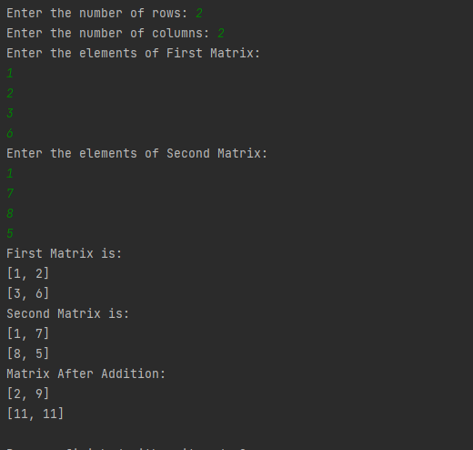
11. Write a program to perform bubble sort on a given set of elements.
PROGRAM
a=[1,2,3,4,10,3,8]
rint("Before sorting array elements are - ")
for i in a:
print(i, end = " ")
for i in range(0,len(a)):
for j in range(i+1,len(a)):
if a[j]<a[i]:
temp = a[j]
a[j]=a[i]
a[i]=temp
print("\nAfter sorting array elements are - ")
for i in a:
print(i, end = " ")
OUTPUT
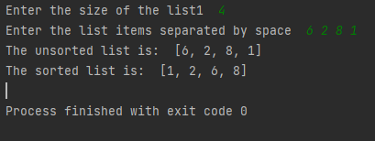
12. Program to find the count of each vowel in a string(use dictionary)
PROGRAM
string=input("Enter string:")
vowels=0
for i in string:
if(i=='a' or i=='e' or i=='i' or i=='o' or i=='u' or i=='A' or i=='E' or i=='I' or i=='O' or i=='U'):
vowels=vowels+1
print("Number of vowels are:")
print(vowels)
OUTPUT
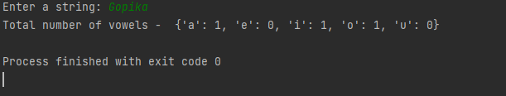
13. Write a Python program that accept a positive number and subtract from this
number the sum of its digits and so on. Continues this operation until the number is
positive
PROGRAM
def repeat_times(n):
s = 0
n_str = str(n)
while (n > 0):
n -= sum([int(i) for i in list(n_str)])
n_str = list(str(n))
s += 1
return s
print(repeat_times(9))
print(repeat_times(21))

OUTPUT
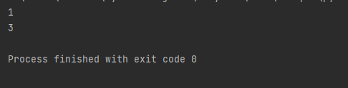
14. Write a Python program that accepts a 10 digit mobile number, and find the digits
which are absent in a given mobile number
PROGRAM
def absent_digits(n):
all_nums = set([0,1,2,3,4,5,6,7,8,9])
n = set([int(i) for i in n])
n = n.symmetric_difference(all_nums)
n = sorted(n)
return n
print(absent_digits([9,8,3,2,2,0,9,7,6,3]))
OUTPUT
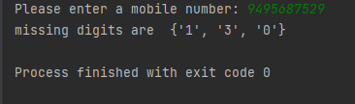

CYCLE-2

PART-1
1. Create a three dimensional array specifying float data type and print it.
Program
import numpy as np
arr=np.array([[[1, 2, 3], [4, 5, 6]], [[1, 2, 3], [4, 5, 6]]],dtype='f')
print(arr)
output
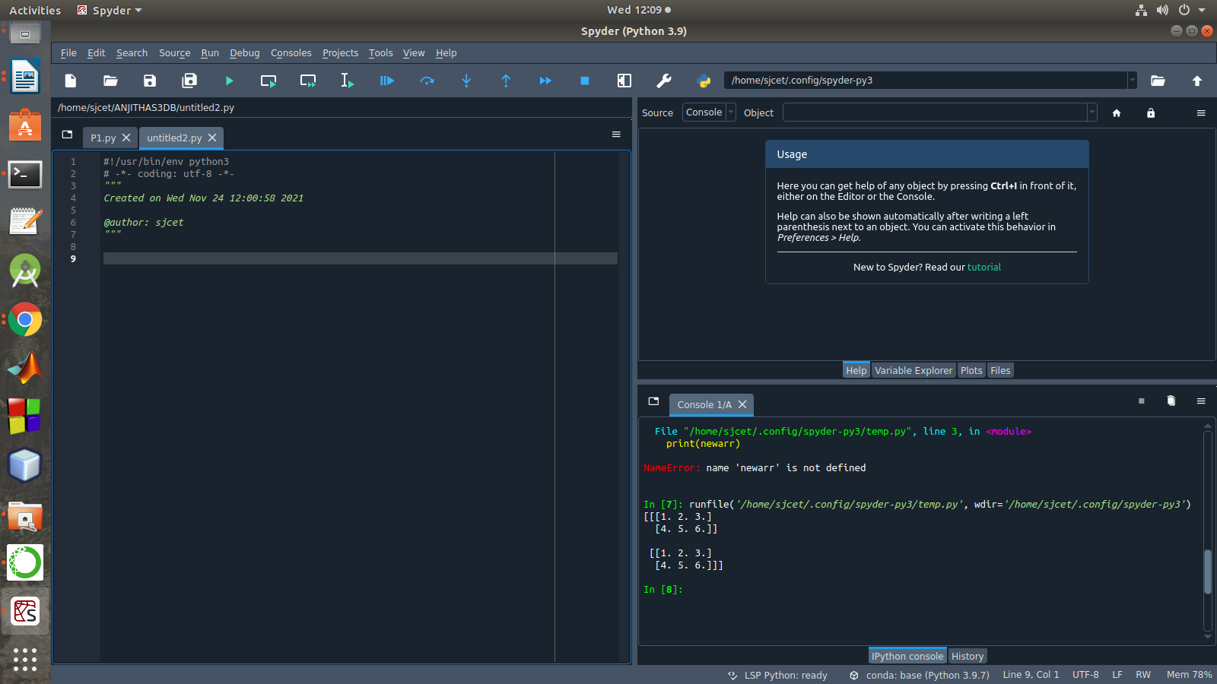

2. Create a 2 dimensional array (2X3) with elements belonging to complex data
type and print it. Also display
a. the no: of rows and columns
b. dimension of an array
c. reshape the same array to 3X2
program
import numpy as np
x = np.array([[2, 4, 6], [6.5, 8, 10]])
print(type(x))
print(x)
numOfRows = np. size(x, 0)
print(numOfRows)
numOfColumns = np. size(x, 1)
print(numOfColumns)
print("No. of dimensions: ", x.ndim)
rs=np.reshape(x, (3, 2))
print(rs)
output
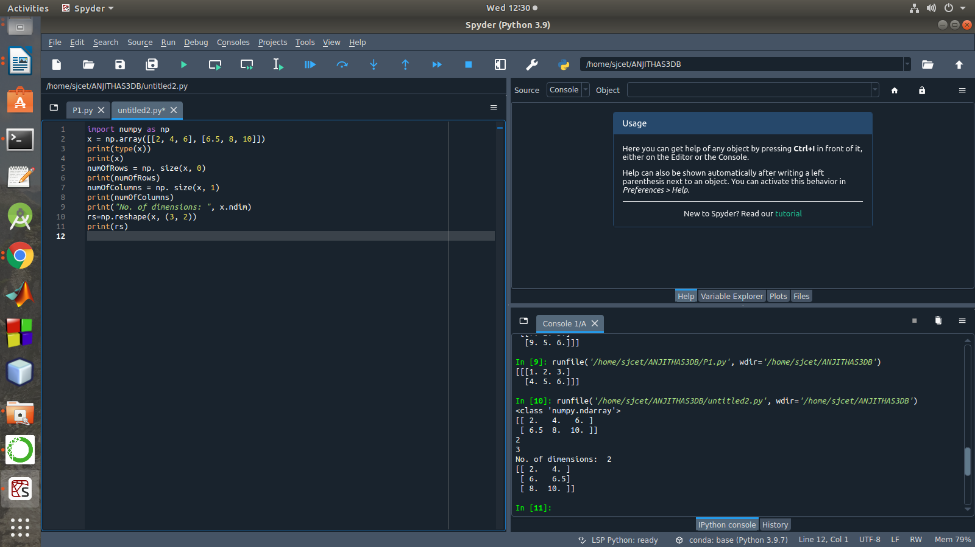

3. Familiarize with the functions to create
a) an uninitialized array
b) array with all elements as 1,
c) all elements as 0
program
import numpy as np
x=np.empty([2, 2])
print(x)
y=np.full((2, 2), 1)
print(y)
z=np.full((2, 2), 0)
print(z)
output
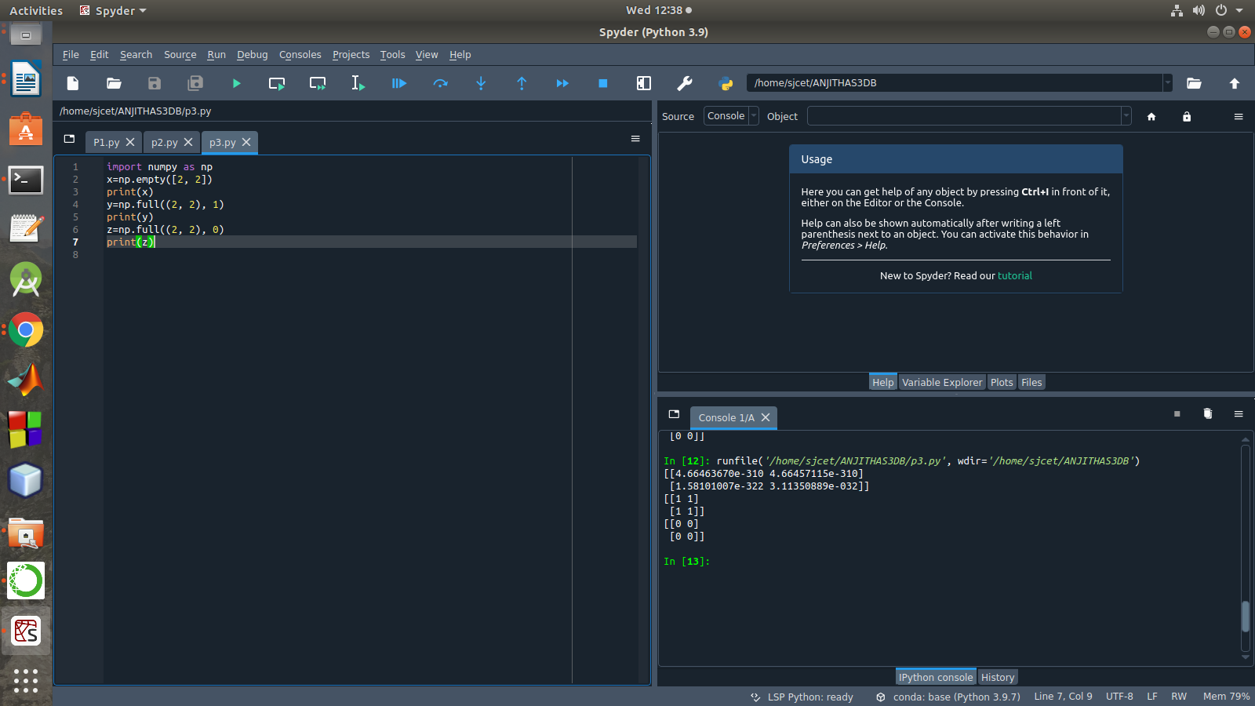

4. Create an one dimensional array using arange function containing 10 elements.
Display
a. First 4 elements
b. Last 6 elements
c. Elements from index 2 to 7
program
import numpy as np
a = np.arange(1, 11, 1)
print(a)
first_element = a[:4]
print(first_element)
first_element1 = a[5:]
print(first_element1)
first_element2 = a[1:7]
print(first_element2)
output
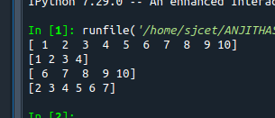

5. Create an 1D array with arange containing first 15 even numbers as elements
a. Elements from index 2 to 8 with step 2(also demonstrate the same
using slice function)
b. Last 3 elements of the array using negative index
c. Alternate elements of the array
d. Display the last 3 alternate elements
program
import numpy as np
a = np.arange(0, 15, 2)
print(a)
print("Elements from index 2 to 8 with step 2")
s2 = slice(2, 8, 2)
print(a[s2])
print("Last 3 elements of the array using negative index",a[-3:-1])
print("Alternate elements of the array")
ab = np.arange(1, 15, 2)
print(ab)
print("Display the last 3 alternate elements",a[-3:-1:2])

output
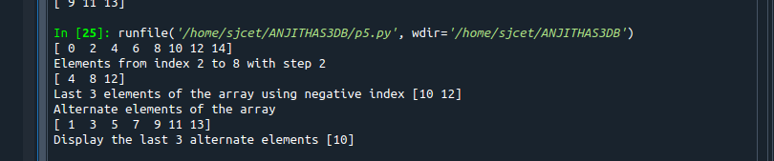

6. Create a 2 Dimensional array with 4 rows and 4 columns.
a. Display all elements excluding the first row
b. Display all elements excluding the last column
c. Display the elements of 1 st and 2 nd column in 2 nd and 3 rd row
d. Display the elements of 2 nd and 3 rd column
e. Display 2 nd and 3 rd element of 1 st row
program
import numpy as np
x = np.array([[2, 4, 6,1], [6, 8, 10,1],[1, 2, 1,1], [1, 1, 1,1]])
print(x)
print("Display all elements excluding the first row")
print(x[1:])
print("Display all elements excluding the last column")
print(x[:, :3])
print("Display the elements of 2 nd and 3 rd column")
print(x[:, 1:3])
print("Display the elements of 1 st and 2 nd column in 2 nd and 3 rd row")
print(x[1:3,1:3])
print("Display 2 nd and 3 rd element of 1 st row")
print(x[0,1])
print(x[0,2])
output
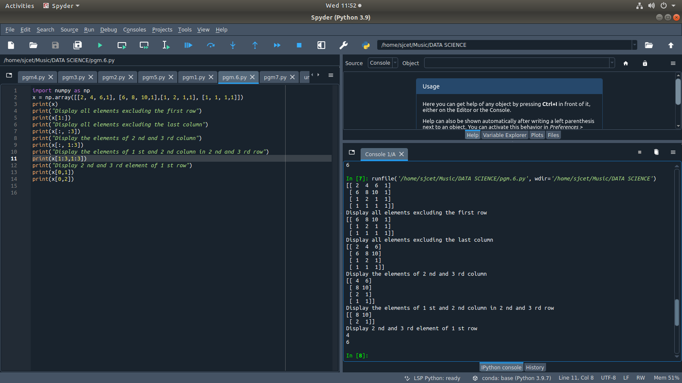
7. Create two 2D arrays using array object and
a. Add the 2 matrices and print it
b. Subtract 2 matrices
c. Multiply the individual elements of matrix
d. Divide the elements of the matrices
e. Perform matrix multiplication
f. Display transpose of the matrix
g. Sum of diagonal elements of a matrix
program
import numpy as np
M1 = np.array([[3, 6], [14, 21]])
M2 = np.array([[9, 27], [11, 22]])
M3 = M1 + M2
print("Matrix addition")
print(M3)
M1 = np.array([[3, 6], [14, 21]])
M2 = np.array([[9, 27], [11, 22]])
M3 = M1 - M2
print("Matrix Substract")
print(M3)
M1 = np.array([[3, 6], [14, 21]])
M2 = np.array([[9, 27], [11, 22]])
M3 = M1 / M2
print("Divide the elements of the matrices")
print(M3)
M1 = np.array([[3, 6], [5, -10]])
M2 = np.array([[9, -18], [11, 22]])
M3 = M1 * M2
print("Multiply the individual elements of matrix")
print(M3)
M1 = np.array([[3, 6], [5, -10]])
M2 = np.array([[9, -18], [11, 22]])
M3 = M1.dot(M2)
print("matrix multiplication")
print(M3)
M1 = np.array([[3, 6, 9], [5, -10, 15], [4,8,12]])
M2 = M1.transpose()
print("Transpose of the matrix")
print(M2)
M1 = np.array([[3, 6, 9], [5, -10, 15], [4,8,12]])
print("Sum of diagonal elements of a matrix")
print(np.trace(M1))
output
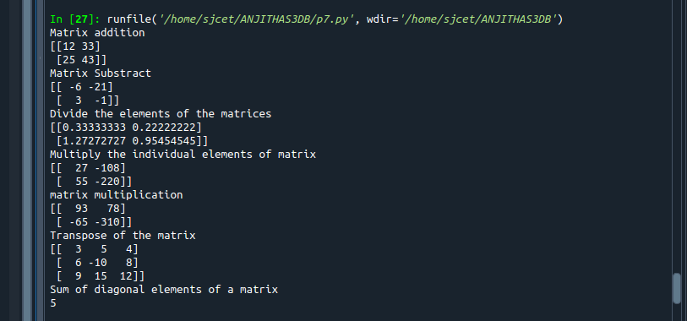

8.Demonstrate the use of insert() function in 1D and 2D array
program
import numpy as np
arr1 = np.arange(10, 16)
print("1D ARRAY ")
print("The array is: ", arr1)
obj = 2
value = 40
arr = np.insert(arr1, obj, value, axis=None)
print("After inserting the new array is: ")
print(arr)
print("Shape of the new array is : ", np.shape(arr))
print("2D ARRAY ")
arr1 = np.array([(1, 2, 3), (4, 5, 6), (7, 8, 9), (50, 51, 52)])
print("The array is: ")
print(arr1)
print("The shape of the array is: ", np.shape(arr1))
a = np.insert(arr1, 1, [[50], [100], ], axis=0)
print("New array is : ")
print(a)
print("Shape of the array is: ", np.shape(a))
output
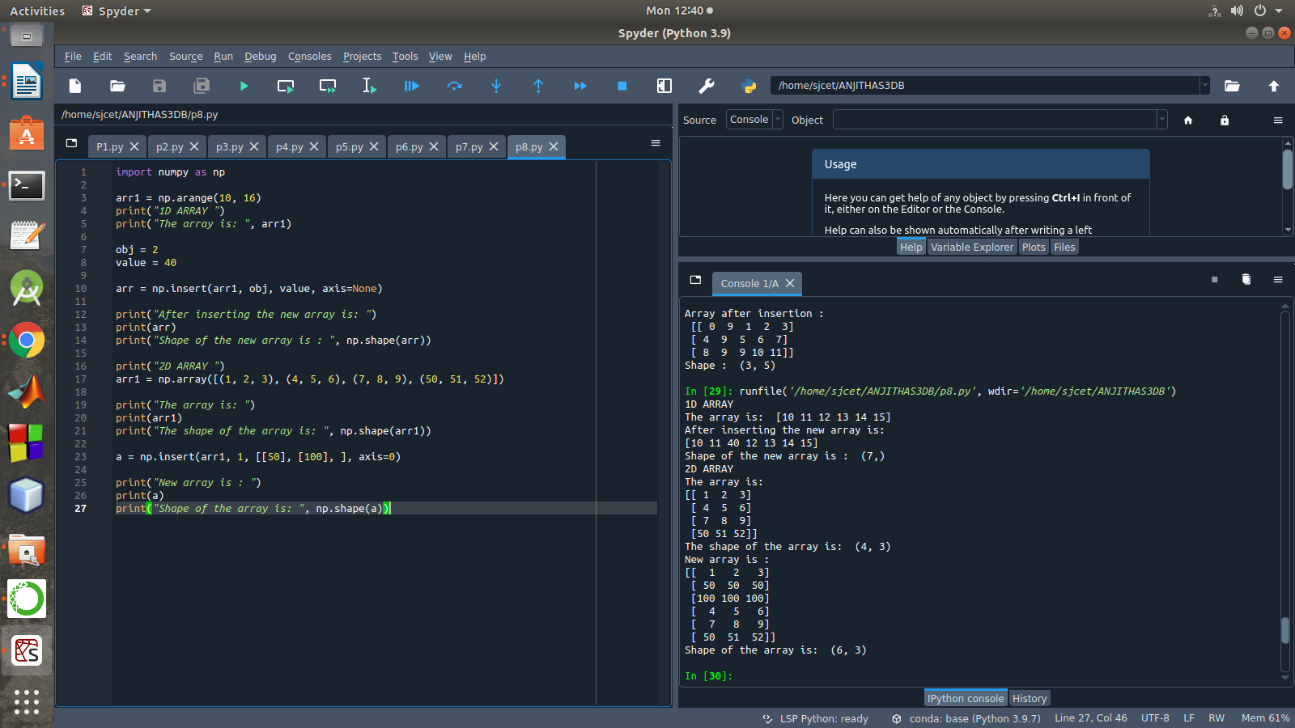

9. Demonstrate the use of diag() function in 1D and 2D array.
Program
import numpy as np
a= np.array([[3, 6,7,8]])
b=np.array([[3, 6,8,7], [4, 2,1,0],[3,1,3,3],[1,1,2,2]])
x=np.diag(a)
y=np.diag(b)
print(x)
print(y)
output
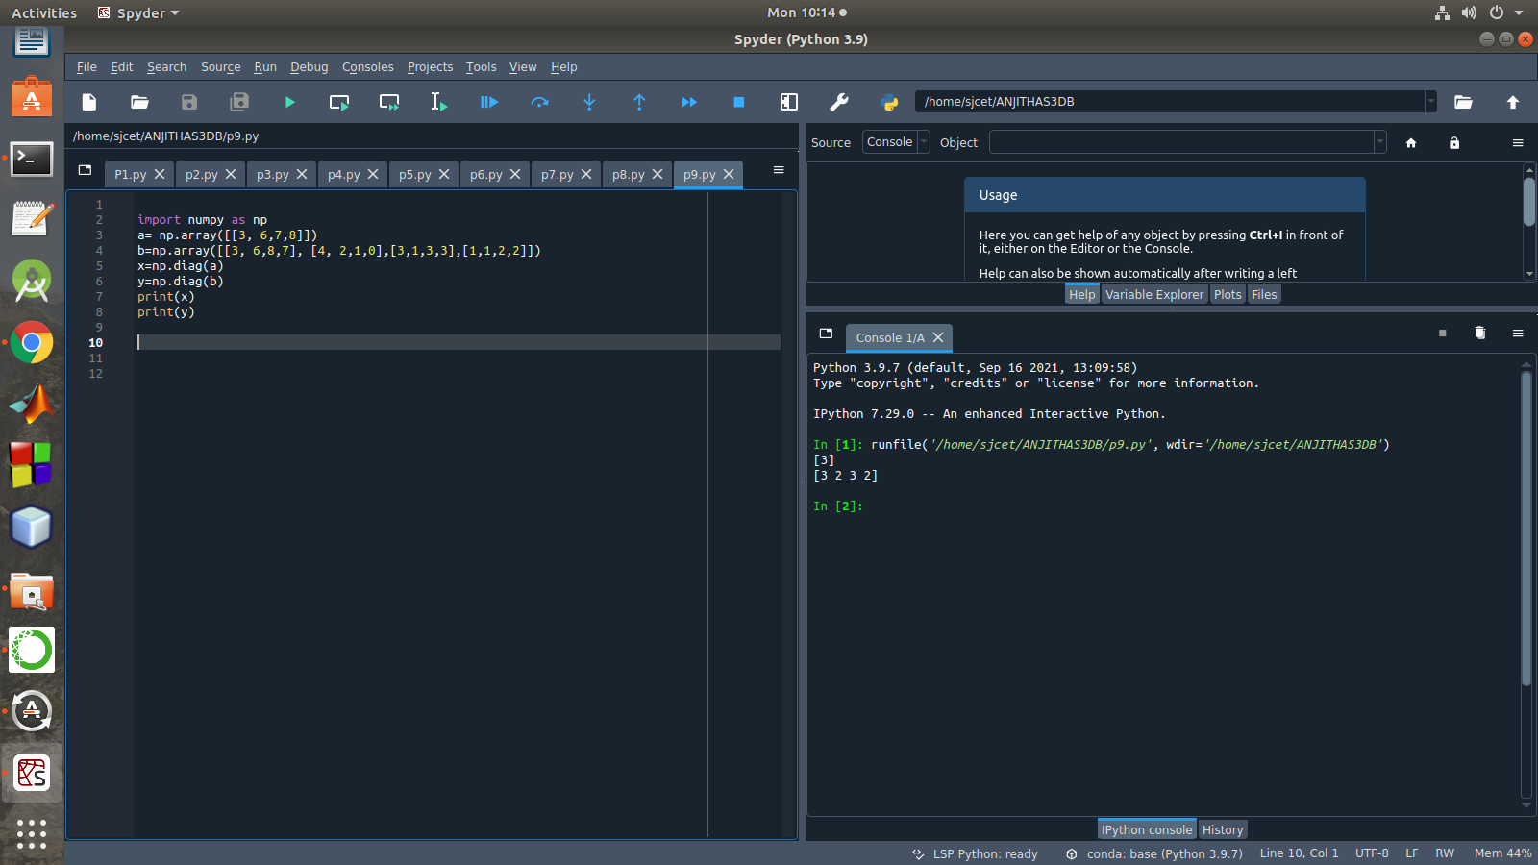

10. Demonstarte the use of append() function in 1D and 2D
array.
Program
import numpy as np
a = np.array([[1,2,3],[4,5,6]])
b=np.array([1,2,3])
print("First array:")
print (a)
print("Second array")
print(b)
print ("\n")
print ("Append elements to array:")
print (np.append(a, [7,8,9]))
print (np.append(b, [7,8,9]))
output
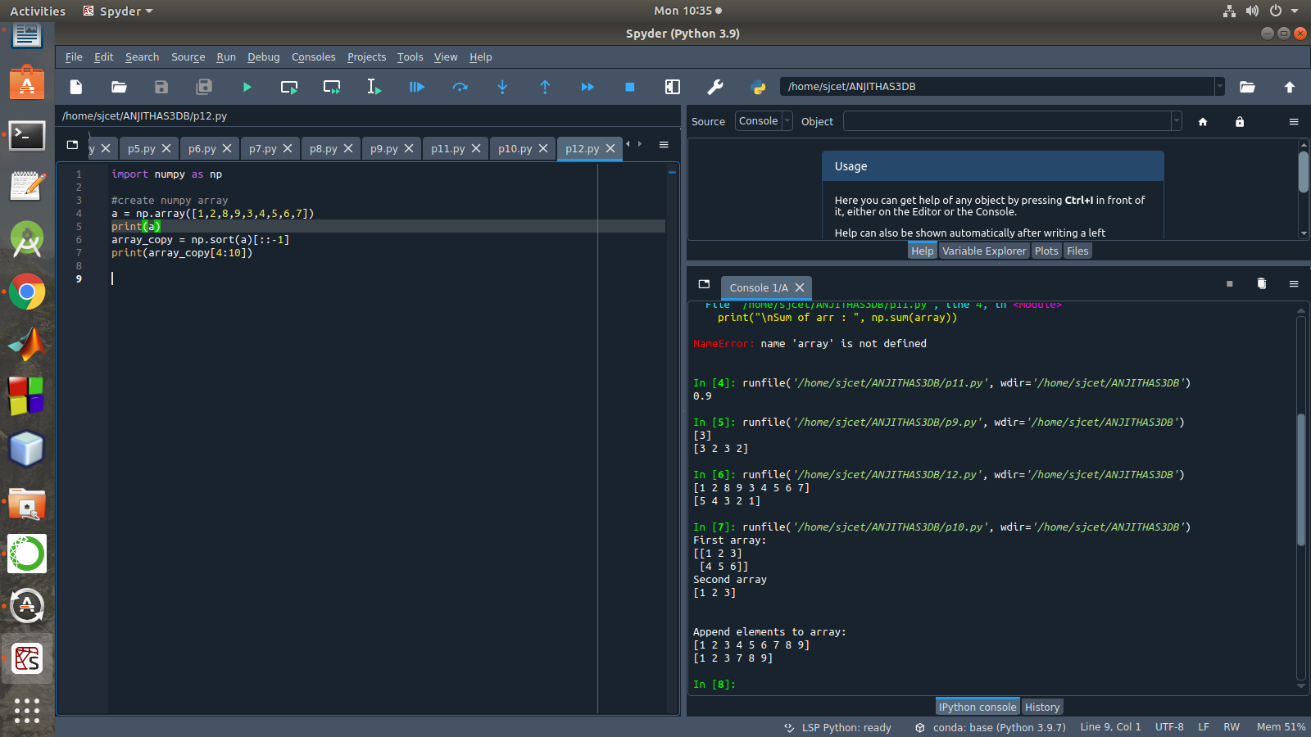

11. Demonstarte the use of sum() function in 1D and 2D array.
Program
import numpy as np
a=np.array([0.4,0.5])
b=np.sum(a)
print (b)
output

12. Display the elements from indices 4 to 10 in descending order(use
–values)
program
import numpy as np
a = np.array([1,2,8,9,3,4,5,6,7])
print(a)
array_copy = np.sort(a)[::-1]
print(array_copy[4:10])

output

part-2
1.Create a square matrix with random integer values(use randint()) and use appropriate functions to find:
i) inverse
ii) rank of matrix
iii) Determinant
iv) transform matrix into 1D array
v) eigen values and vectors
program
import numpy as np
import numpy as nf
from numpy.linalg import eig
mat = np.random.randint(10, size=(3, 3))
array = nf.random.randint(10, size=(3, 3))
print(mat)
M_inverse = np.linalg.inv(mat)
print("inverse of the array")
print(M_inverse)
rank = np.linalg.matrix_rank(mat)
print("Rank of the given Matrix ")
print(rank)
det= np.linalg.det(mat)
print("determinant of the given Matrix ")
print(det)
arr=mat.flatten()
print("transform matrix to array ")
print(arr)
w,v=eig(array)
print('E-value:', w)
print('E-vector', v)

output
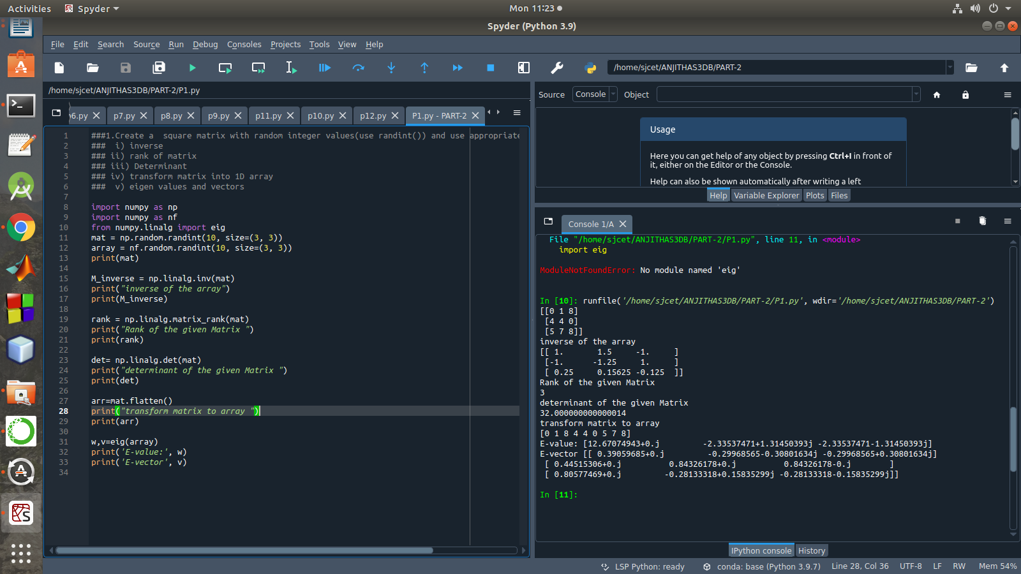

2. Create a matrix X with suitable rows and columns
i) Display the cube of each element of the matrix using different methods
(use multiply(), *, power(),**)
ii) Display identity matrix of the given square matrix.
iii) Display each element of the matrix to different powers.
iv) Create a matrix Y with same dimension as X and perform the operation X²+2Y
program
import numpy as np

matrix=np.random.randint(0,10,4).reshape(2,2)
print("Display the cube of each element of the matrix using different methods (use multiply(), *, power(),**)")
x=np.power(matrix,3)
print("power()",x)

y=np.multiply(matrix,(matrix*matrix))
print("multiply()")
print(y)

z=matrix*matrix*matrix
print("**")
print(z)

cube=matrix*3
print("*")
print(cube)

print("Display identity matrix of the given square matrix.")
identity=np.identity(2,dtype=int)
print(identity)

print("Display each element of the matrix to different powers.")
dpow=np.power(matrix,matrix)
print(dpow)

print("Create a matrix Y with same dimension as X and perform the operation X^2 +2Y")
a=np.add((np.power(x,2)),(np.multiply(y,2)))
print(a)
output
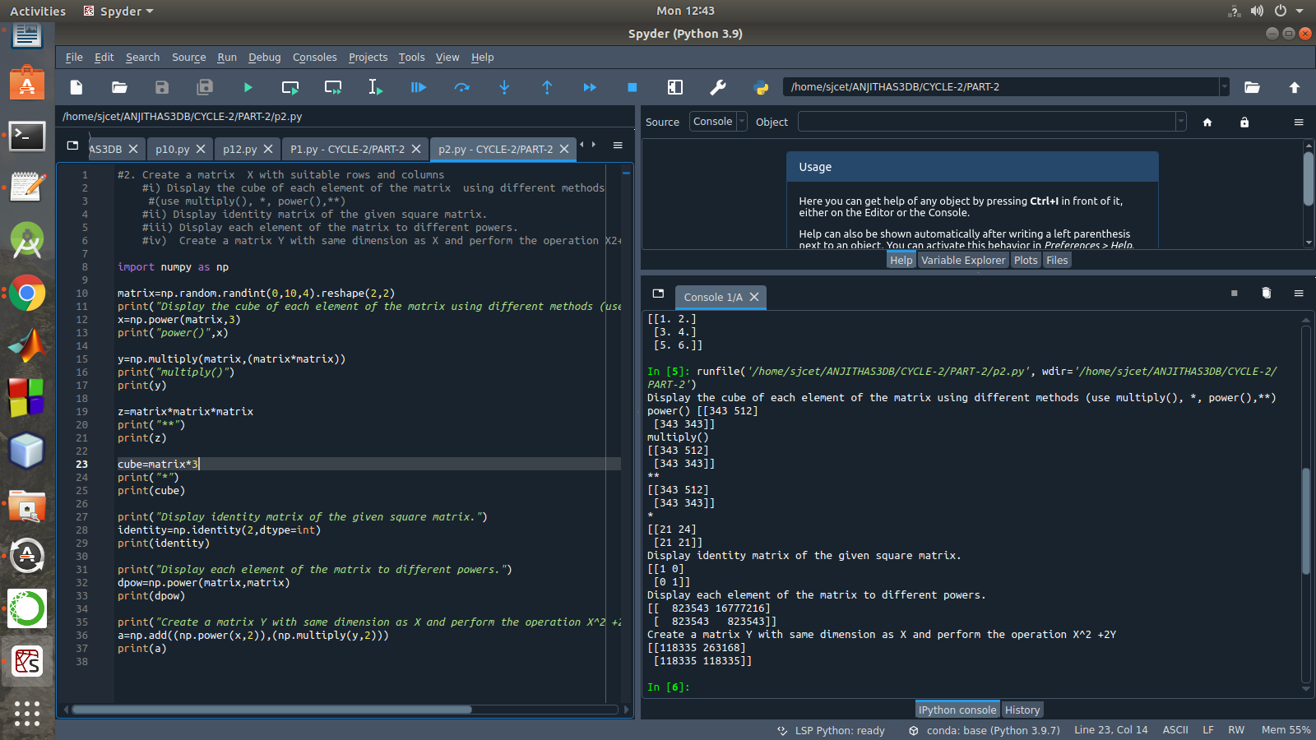

3. Multiply a matrix with a submatrix of another matrix and replace the same in larger matrix.
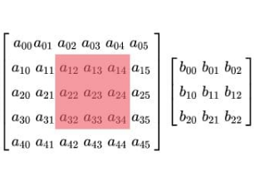

program
iimport numpy as np
A = np.array([[6, 1, 1,6,3],
[4, -2, 5,1,3],
[2, 8, 7,7,8],
[6, 1, 1,6,3],
[2, 8, 7,7,8]])
B=np.array([[2, 1, -2],
[3, 0, 1],
[1, 1, -1]])
print("Mat A=\n",A)
print("Mat B=\n",B)
C=A[:3, :3]
res = np.dot(B,C)
print("Multiplication Result\n",res)
A[:3,:3]=res[:3,:3]
print("Resultant Matrix:\n",A)
output
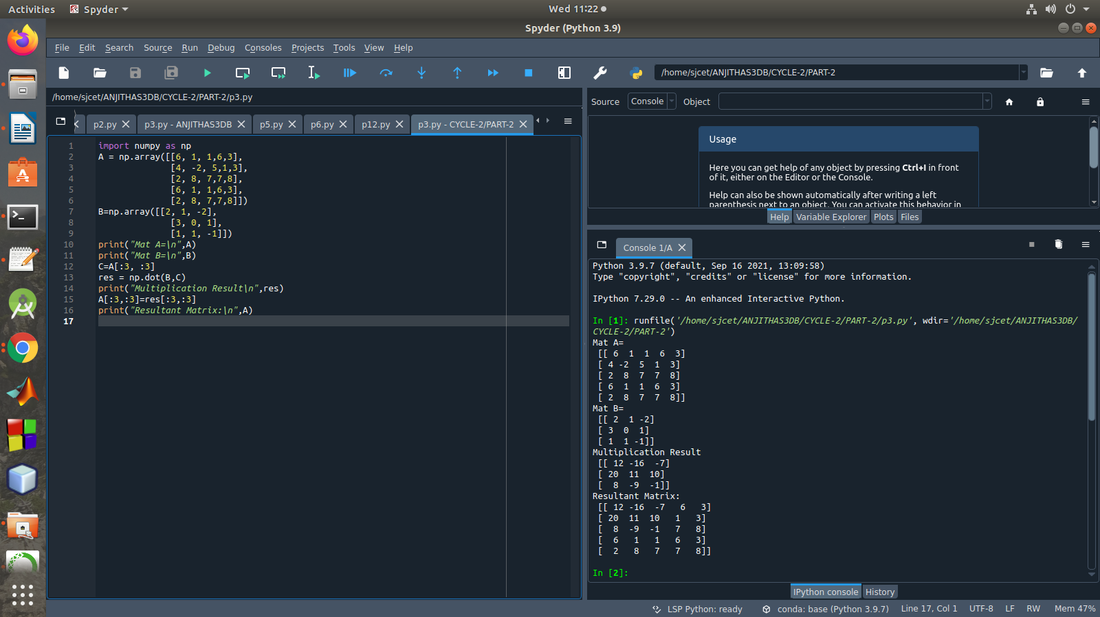

4. Given 3 Matrices A, B and C. Write a program to perform matrix multiplication of the 3 matrices.
Program
import numpy as np
m1 = np.random.randint(20, size=(2, 2))
print(m1)
m2 = np.random.randint(20, size=(2, 2))
print(m2)
m3 = np.random.randint(20, size=(2, 2))
print(m3)
print("multiplication of the 3 matrices")
m4 = np.dot(m1,m2,m3)
print(m4)
output
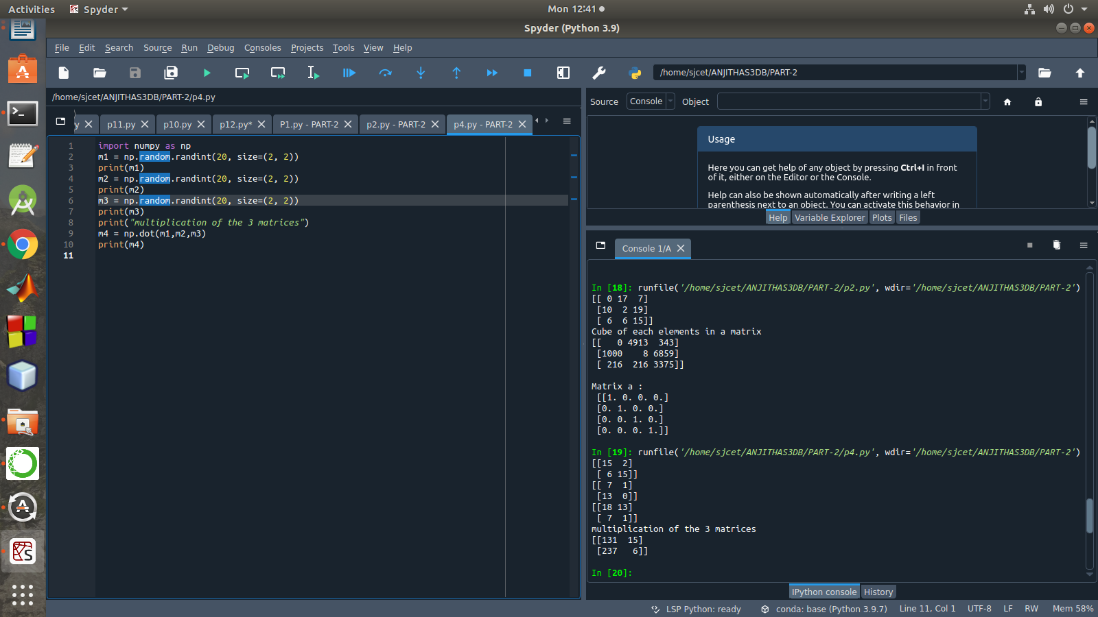

5. Write a program to check whether given matrix is symmetric or Skew Symmetric.

Solving systems of equations with numpy
One of the more common problems in linear algebra is solving a matrix-vector equation.

Here is an example. We seek the vector x that solves the equation

A X = b

Where 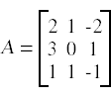 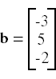
And X=A⁻¹ b.
Numpy provides a function called solve for solving such equations.
Program
import numpy as np
A = np.array([[6, 1, 1],
[4, -2, 5],
[2, 8, 7]])
inv=np.transpose(A)
print (inv)
neg=np.negative(A)
comparison = A == inv
comparison1 = inv== neg
equal_arrays = comparison.all()
skew=comparison1.all()
if equal_arrays :
print("Symmetric")
else:
print("not Symmetric")

if skew:
print("Skew Symmetric")
else:
print("Not Skew Symmetric")

output
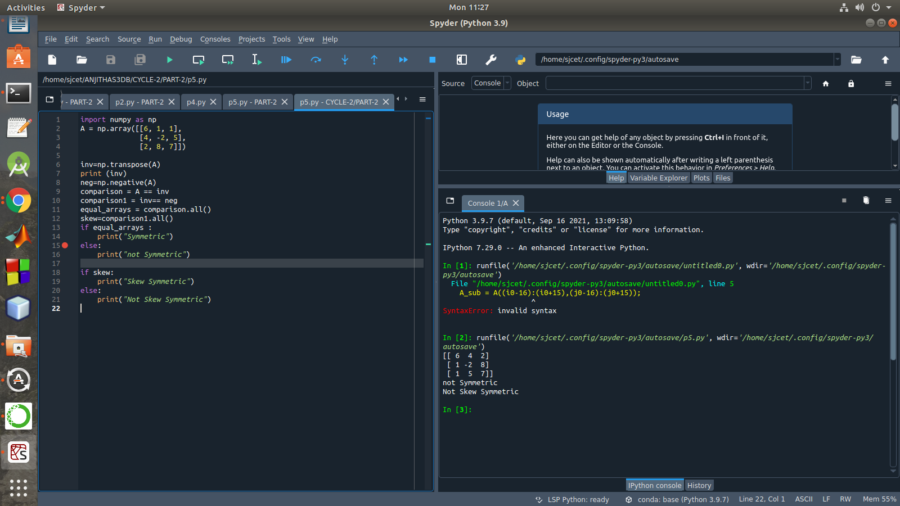

6.Write a program to find out the value of X using solve(), given A and b as above
Singular value Decomposition Matrix decomposition, also known as matrix factorization, involves describing a given matrix using its constituent elements.The Singular-Value Decomposition, or SVD for short, is a matrix decomposition method for reducing a matrix to its constituent parts in order to make certain subsequent matrix calculations simpler. This approach is commonly used in reducing the no: of attributes in the given data set.
M= U ∑V^T
- 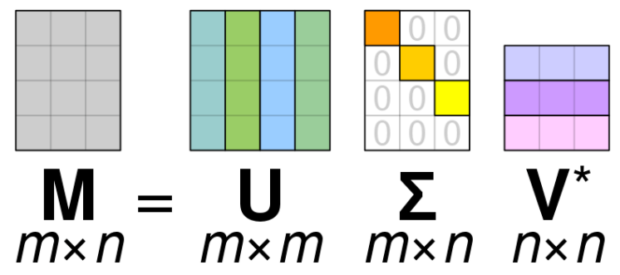M-is original matrix we want to decompose
- U-is left singular matrix (columns are left singular vectors). U columns contain eigenvectors of matrix MMᵗ
- Σ-is a diagonal matrix containing singular (eigen) values.
- V-is right singular matrix (columns are right singular vectors). V columns contain eigenvectors of matrix MᵗM
Numpy provides a function for performing svd, which decomposes the given matrix into 3 matrices.
Program
import numpy as np
A = np.array([[2, 1, -2],
[3, 0, 1],
[1, 1, -1]])
b=np.array([[3],
[5],
[-2]])
inv=np.linalg.inv(A)
x=np.linalg.solve(inv,b)
print(x)
output
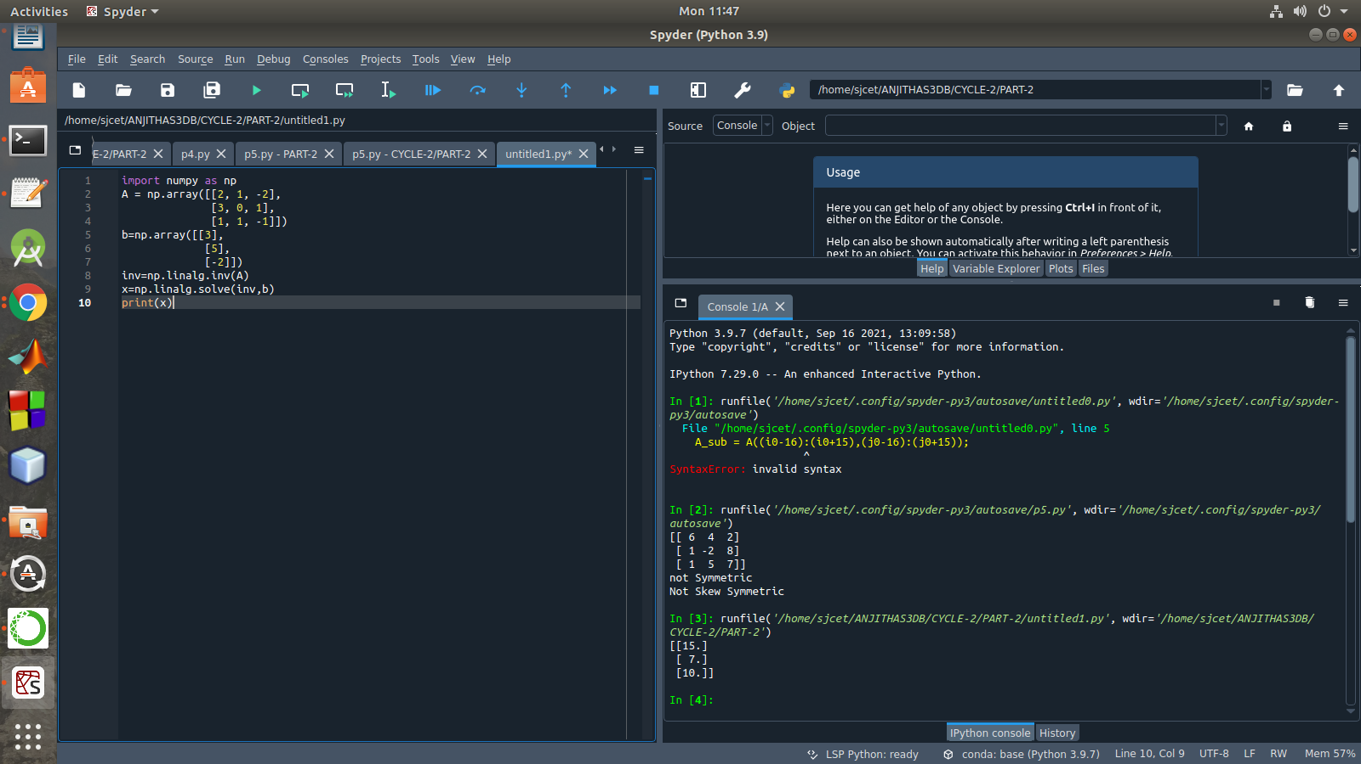

7.Write a program to perform the SVD of a given matrix. Also reconstruct the given matrix from the 3 matrices obtained after performing SVD.
Program
from numpy import array
from scipy.linalg import svd
from numpy import diag
from numpy import dot
from numpy import zeros
# define a matrix
A = array([[1, 2], [3, 4], [5, 6]])
print(A)
# SVD
U, s, VT = svd(A)
print("first" ,U)
print("second",s)
print("3rd" ,VT)
Sigma = zeros((A.shape[0], A.shape[1]))
# populate Sigma with n x n diagonal matrix
Sigma[:A.shape[1], :A.shape[1]] = diag(s)
# reconstruct matrix
B = U.dot(Sigma.dot(VT))
print(B)
output

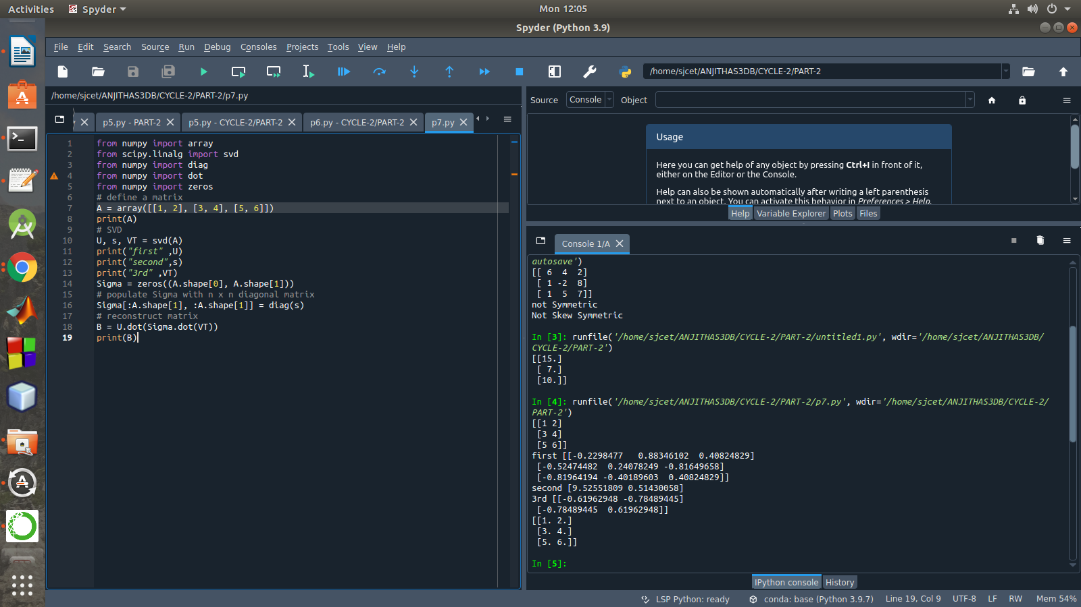

CYCLE-3

CYCLE-3
PART-A
Mathplotlib
Demonstrate creating various types of charts and plots using functions in mathplotlib library

- Sarah bought a new car in 2001 for $24,000. The dollar value of her car changed each year as shown in the table below.
Value of Sarah's Car
Year Value
2001 $24,000
2002 $22,500
2003 $19,700
2004 $17,500
2005 $14,500
2006 $10,000
2007 $ 5,800
Represent the following information using a line graph with following style properties
- X- axis - Year
Y –axis - Car Value
- title –Value Depreciation (left Aligned)
- Line Style dashdot and Line-color should be red
- point using * symbol with green color and size 20
Subplot() provides multiple plots in one figure.
PROGRAM
import matplotlib.pyplot as plt
import numpy as np
xpoints = np.array([2001, 2002,2003,2004,2005,2006,2007])
ypoints = np.array([24000, 22500,19700,17500,14500,10000,5800])
plt.plot(xpoints, ypoints, '*g',ms = 20)
plt.plot(xpoints, ypoints, ':r')
leg = plt.legend(title="Value Depreciation ")
leg._legend_box.align = "left"
plt.show()
OUTPUT
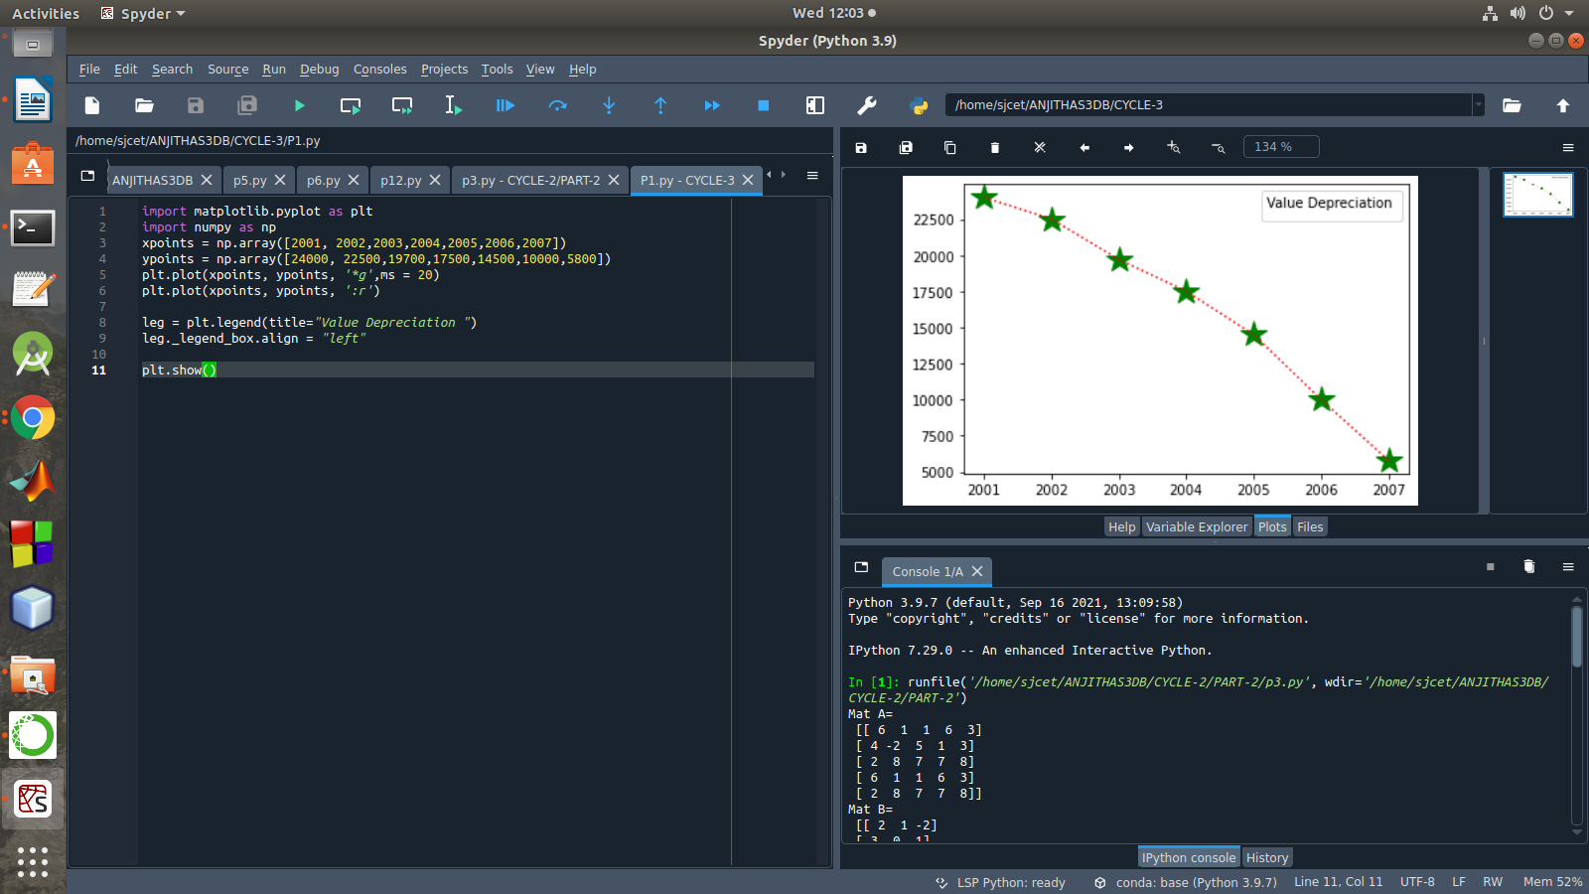

- Following table gives the daily sales of the following items in a shop
Day | Mon | Tues | Wed | Thurs | Fri
Drinks | 300 | 450 | 150 | 400 | 650
Food | 400 | 500 | 350 | 300 | 500

Use subplot function to draw the line graphs with grids(color as blue and line style dotted) for the above information as 2 separate graphs in two rows
- Properties for the Graph 1:
- X label- Days of week
- Y label-Sale of Drinks
- Title-Sales Data1 (right aligned)
- Line –dotted with cyan color
- Points- hexagon shape with color magenta and outline black

- Properties for the Graph 2:
- X label- Days of Week
- Y label-Sale of Food
- Title-Sales Data2 ( center aligned)
- Line –dashed with yellow color
- Points- diamond shape with color green and outline red
PROGRAM
import matplotlib.pyplot as plt
import numpy as np
#plot 1:
x = np.array(['mon', 'tue', 'wed', 'thur','fri'])
y = np.array([300, 450, 150, 400,65])
plt.subplot(1, 2, 1)
plt.title("Sales Data1")
plt.xlabel("Days of week")
plt.ylabel("Sale of Drinks")
plt.plot(x,y,':c')
plt.plot(x,y,'Hm',mec = 'k')
plt.grid(color = 'blue', linestyle = 'dotted')
#plot 2:
c = np.array(['mon', 'tue', 'wed', 'thur','fri'])
v = np.array([400, 500, 350, 300,500])
plt.subplot(1, 2, 2)
plt.title("Sales Data2")
plt.xlabel("Days of Week")
plt.ylabel("Sale of Food")
plt.plot(c,v,'--y')
plt.plot(c,v,'Dg',mec = 'r')
plt.grid(color = 'blue', linestyle = 'dotted')
plt.show()
OUTPUT

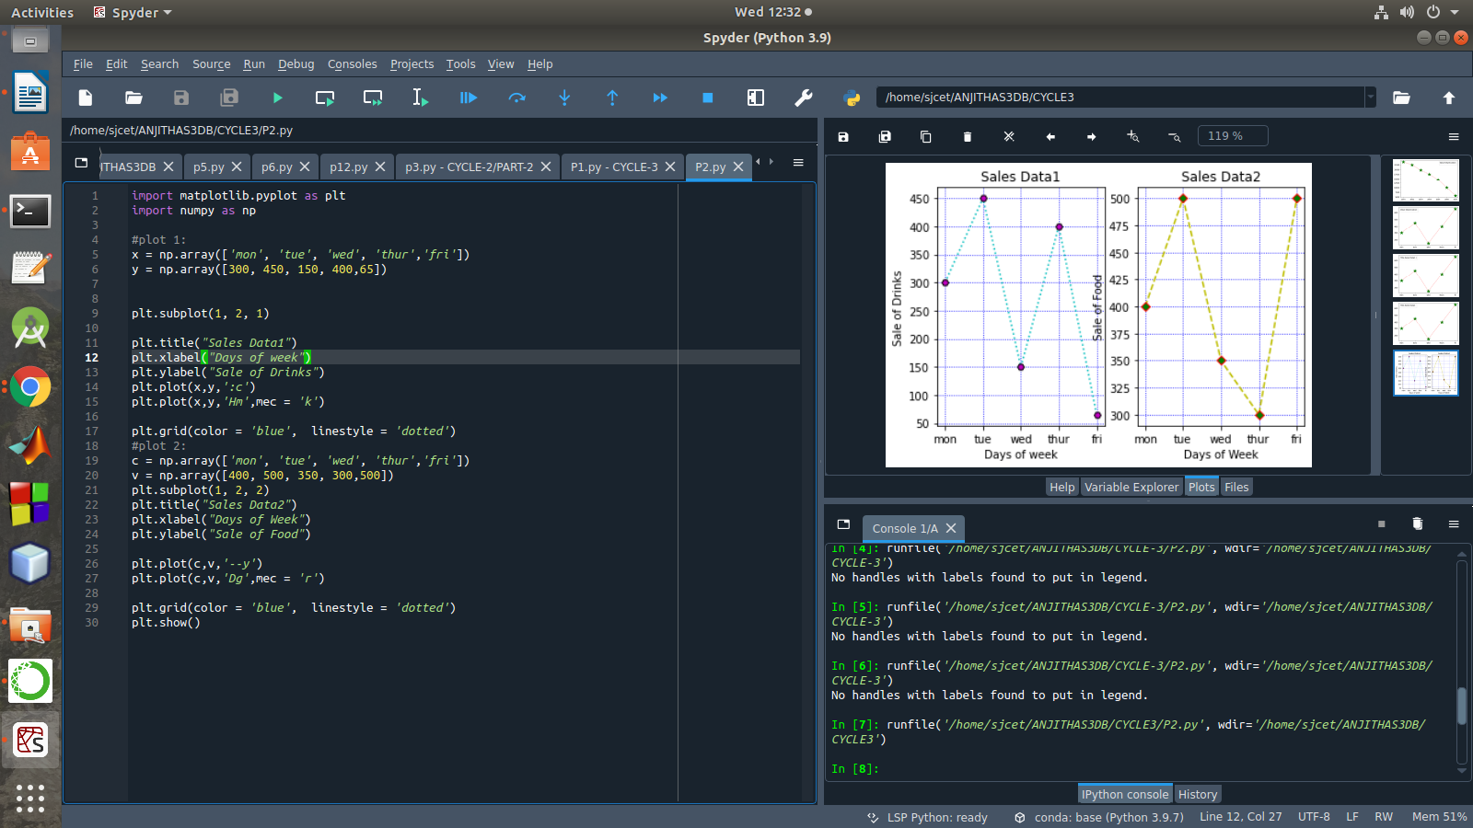

- Create scatter plot for the below data:(use Scatter function)
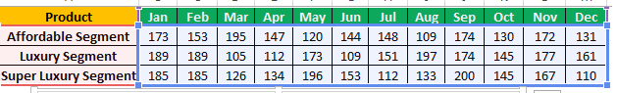

Create scatter plot for each Segment with following properties within one graph
- X Label- Months of Year with font size 18
- Y-Label- Sales of Segments
- Title –Sales Data
- Color for Affordable segment- pink
- Color for Luxury Segment- Yellow
- Color for Super luxury segment-blue
PROGRAM
import matplotlib.pyplot as plt
import numpy as np
plt.title("Sales Data")
plt.xlabel("Months of Year"size=18)
plt.ylabel("Sale of Food")
x = np.array(['Jan','Feb','Mar','Apr','May','Jun','Jul','Aug','Sep','Oct','Nov','Dec'])
y1 = np.array([173,153,195,147,120,144,148,109,174,130,172,131])
plt.scatter(x,y1, color = 'hotpink')
y2 = np.array([185,185,126,134,196,153,112,133,200,145,167,110])
plt.scatter(x, y2, color = 'yellow')
y3 = np.array([189,189,105,112,173,109,151,197,174,145,177,161])
plt.scatter(x, y3, color = 'blue')
plt.show()
OUTPUT
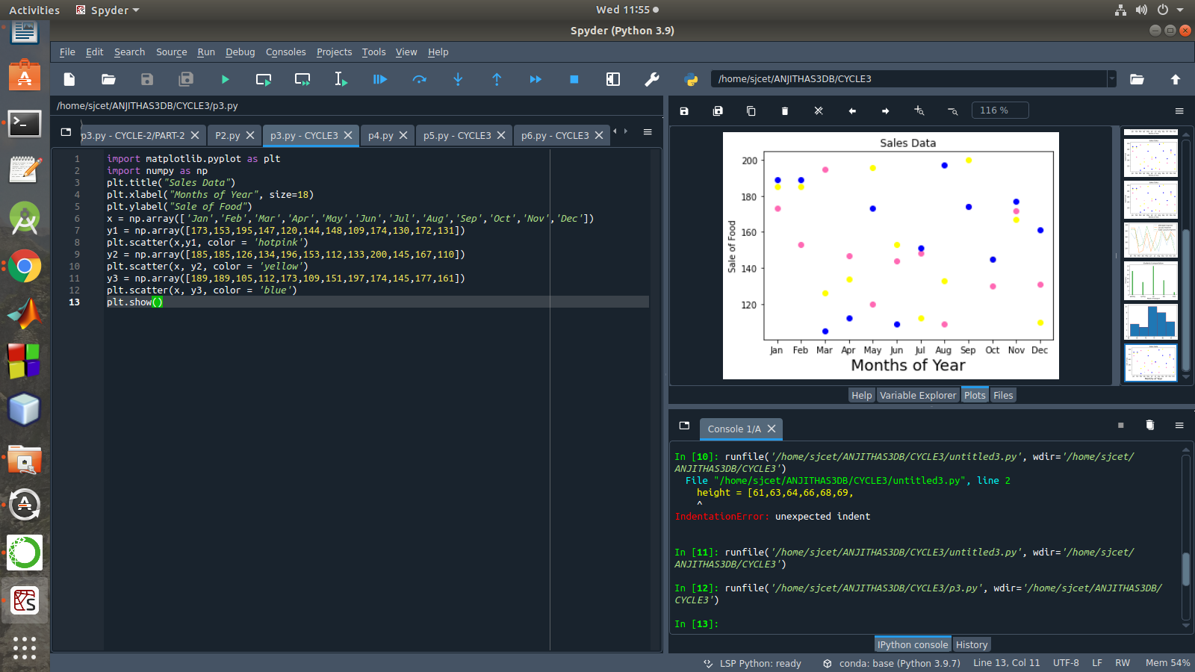

- Display the above data using multiline plot( 3 different lines in same graph)
- Display the description of the graph in upper right corner(use legend())
- Use different colors and line styles for 3 different lines
PROGRAM
import matplotlib.pyplot as plt
import numpy as np
x = np.array(['Jan','Feb','Mar','Apr','May','Jun','Jul','Aug','Sep','Oct','Nov','Dec'])
y1 = np.array([173,153,195,147,120,144,148,109,174,130,172,131])
y2= np.array([189,189,105,112,173,109,151,197,174,145,177,161])
y3= np.array([185,185,126,134,196,153,112,133,200,145,167,110])
plt.plot(x,y1,label = "Affordable Segment",ls=':')
plt.plot(x,y2,label = "Luxuary Segment",ls="-")
plt.plot(x,y3,label = "Super Luxuary Segment",ls="-.")
plt.legend()
plt.show()

OUTPUT
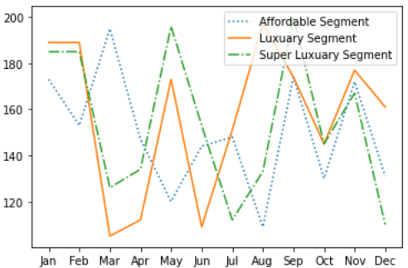

- 100 students were asked what their primary mode of transport for getting to school was. The results of this survey are recorded in the table below. Construct a bar graph representing this information.

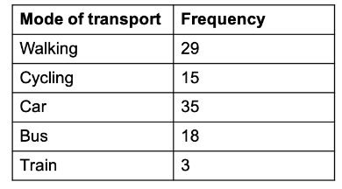
Create a bar graph with
- X axis -mode of Transport and Y axis ‘frequency’
- Provide appropriate labels and title
- Width .1, color green
PROGRAM
import matplotlib.pyplot as plt
import numpy as np
plt.title("Students transportation")
plt.xlabel("Mode of Transport")
plt.ylabel("Frequency")
x = np.array(["walking","cycling","car","bus","train"])
y = np.array([29,15,35,18,3])
plt.bar(x, y, color = "#4CAF50",width = 0.1)
plt.show()
OUTPUT
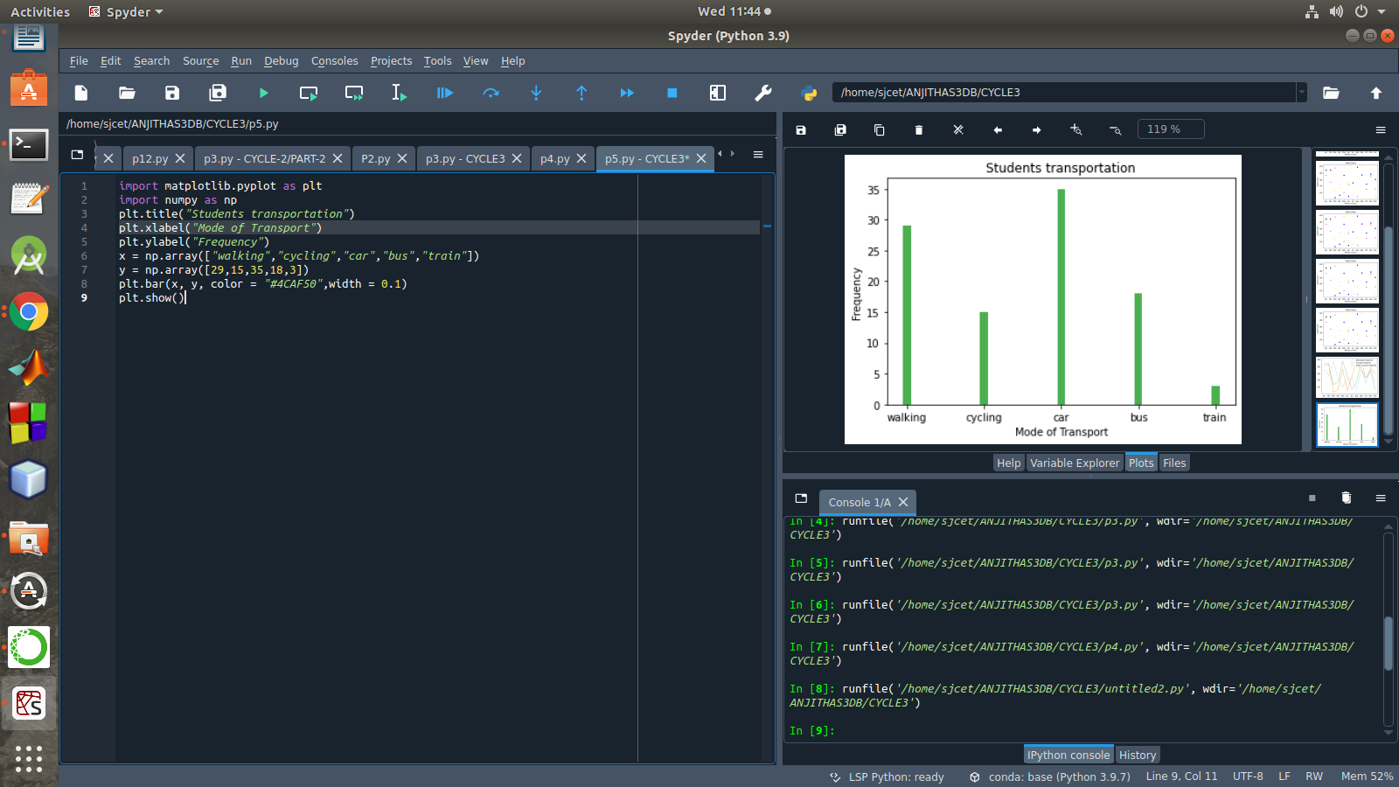

6.We are provided with the height of 30 cherry trees.
The height of the trees (in inches): 61, 63, 64, 66, 68, 69, 71, 71.5, 72, 72.5, 73,73.5, 74, 74.5, 76, 76.2,76.5, 77, 77.5, 78, 78.5, 79, 79.2, 80, 81, 82, 83, 84, 85,87 Create a histogram with a bin size of 5
PROGRAM
import matplotlib.pyplot as plt
height = [61,63,64,66,68,69,
71,71.5,72,72.5,73,73.5,74,74.5,76,76.2,76.5,77,77.5,78,78.5,79,79.2,80,81,82,83,84,85,87
]
plt.hist(height, edgecolor="red", bins=5)
plt.show()
OUTPUT
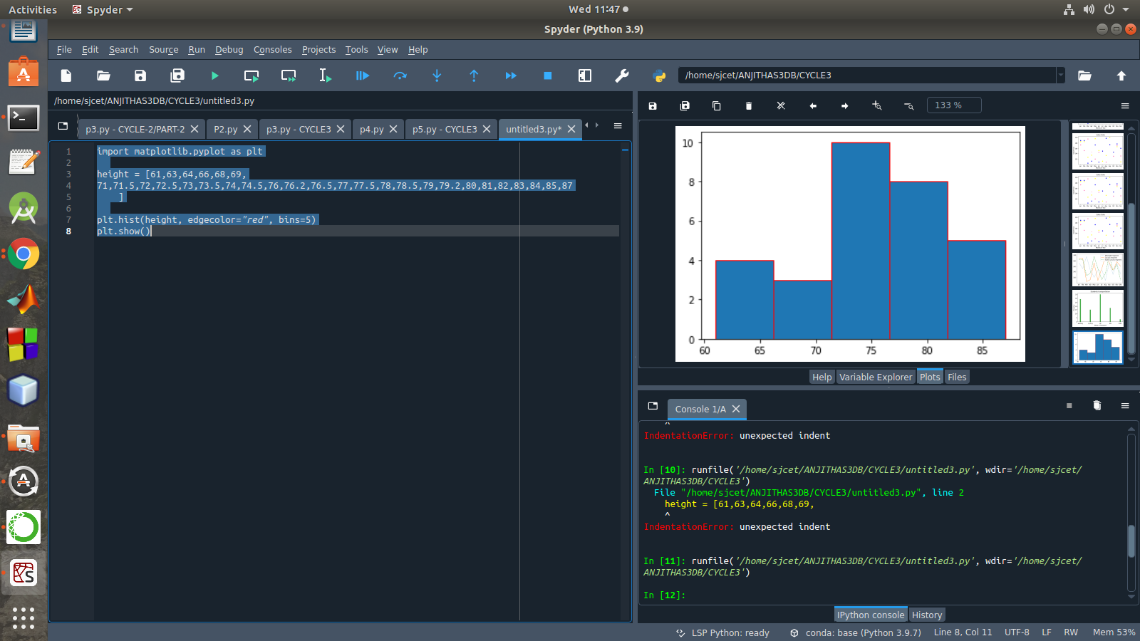

PART-B
1. Use appropriate functions in pandas to display

- Shape of the data set
- First 5 and last five rows of data set(head and tail)
- Size of dataset
- No:of samples available for each variety
- Description of the data set( use describe

PROGRAM
import numpy as np
import matplotlib.pyplot as plt
import seaborn as sns
import pandas as pd
col=['sepal_length','sepal_width','petal_length','petal_width','type']
iris=pd.read_csv("iris.csv",names=col)
print("First five rows")
print(iris.head())
print("*********")
print("columns",iris.columns)
print("*********")
print("shape:",iris.shape)
print("*********")
print("Size:",iris.size)
print("*********")
print("no of samples available for each type")
print(iris["type"].value_counts())
print("*********")
print(iris.describe())
OUTPUT
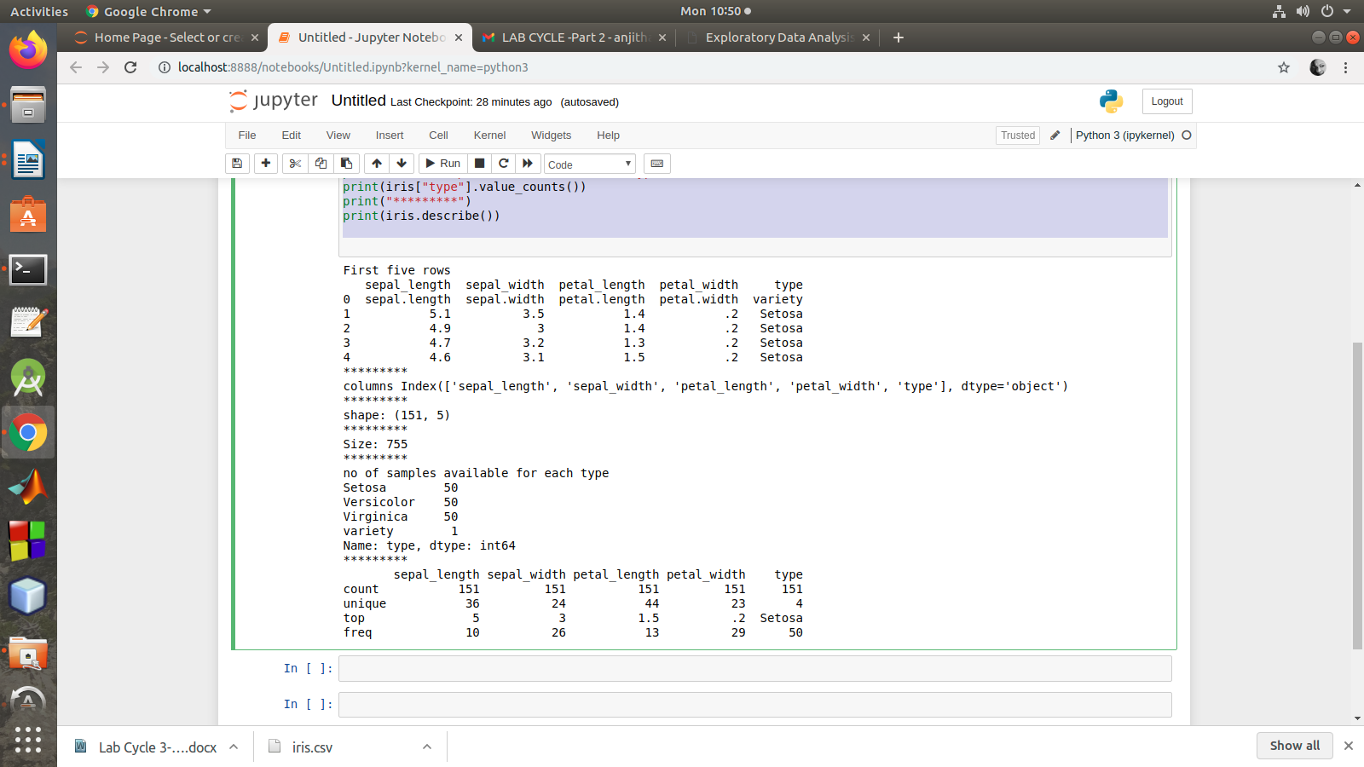
2.Use pairplot() function to display pairwise relationships between attributes. Try different kind of plots {‘scatter’, ‘kde’, ‘hist’, ‘reg’} and different kind of markers
PROGRAM
import numpy as np
import pandas as pd
import seaborn as sns

import matplotlib.pyplot as plt
%matplotlib inline

iris = sns.load_dataset('iris')
my_data_frame = pd.DataFrame(iris)

g = sns.pairplot(my_data_frame)
g = sns.pairplot(iris, kind="reg", hue="species")
g = sns.pairplot(iris, kind="hist", hue="species")
g = sns.pairplot(iris, kind="kde", hue="species")
g = sns.pairplot(iris, kind="scatter", hue="species")

OUTPUT
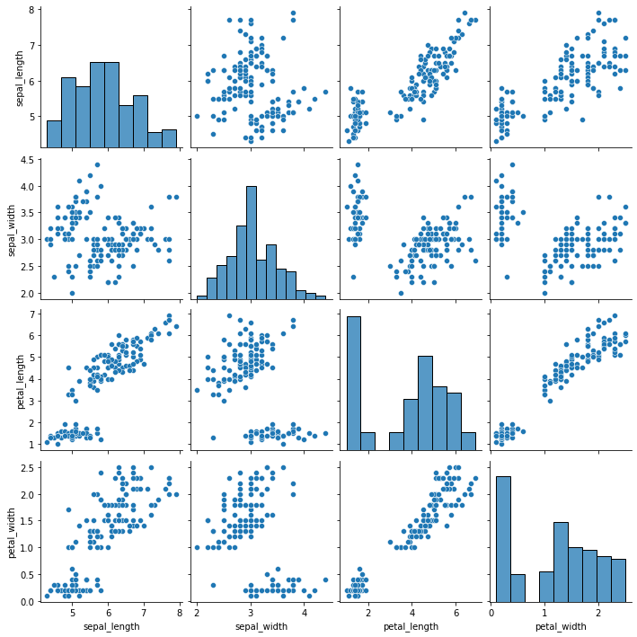

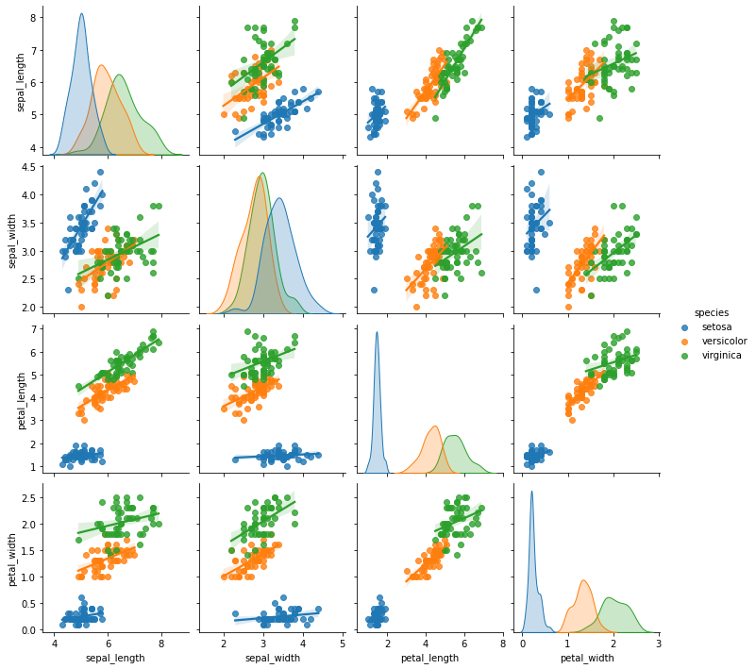

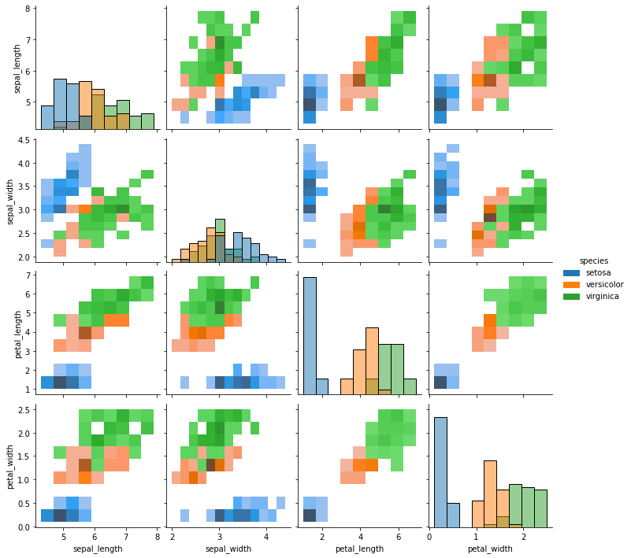
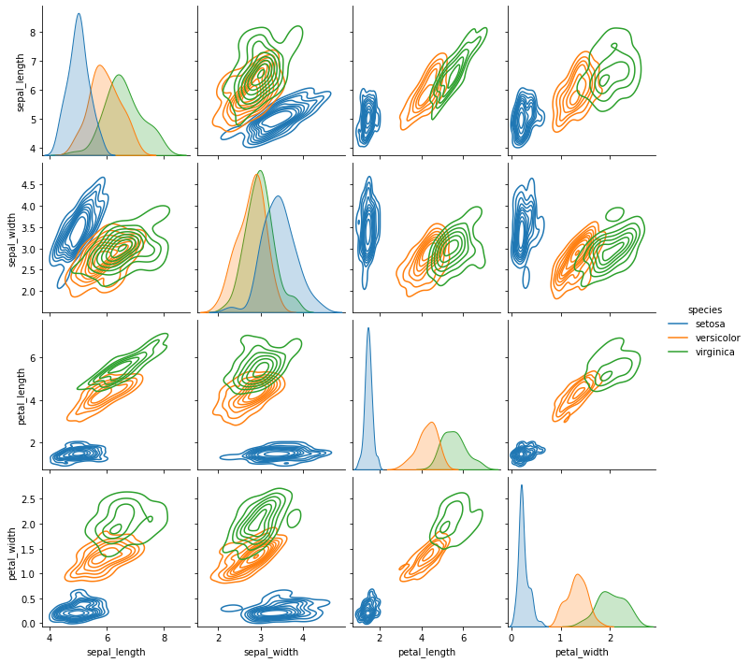

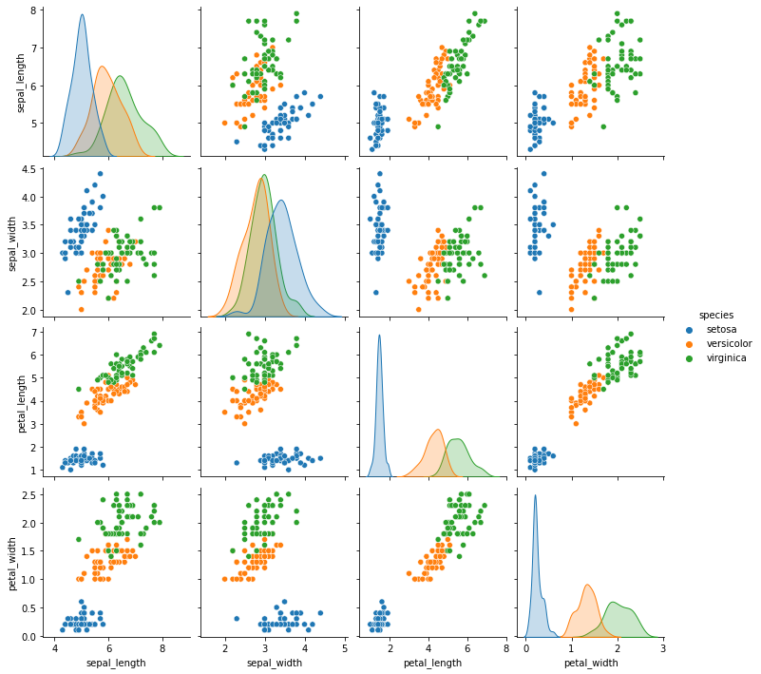
3.using the iris data set,get familiarize with functions:
1)displot()
PROGRAM
import seaborn as sns
import pandas
Import matplotlib.pyplot as plt
sns.get_dataset_names()
df = sns.load_dataset('iris')
df.head()
sns.displot(x = 'sepal_length',kde=True,bins = 5 , data =df)

OUTPUT
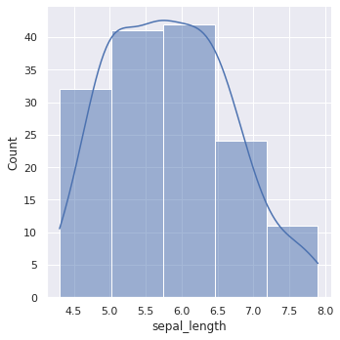

2) histplot()
PROGRAM
import seaborn as sns
import pandas
import matplotlib.pyplot as plt
sns.get_dataset_names()
df = sns.load_dataset('iris')
df.head()
sns.histplot(x = 'sepal_length',kde=True,bins = 6 , data =df)
OUTPUT
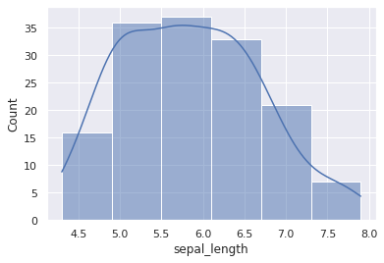

3)relplot()
PROGRAM
import seaborn as sns
sns.set(style ="ticks")
dataset = sns.load_dataset('iris')
col=['sepal_length','sepal_width','petal_length','petal_width','type']
sns.relplot(x ="sepal_length", y ="petal_width", data = dataset)
OUTPUT


